Министерство науки и высшего образования Российской Федерации Федеральное государственное автономное образовательное учреждение высшего образования «НАЦИОНАЛЬНЫЙ ИССЛЕДОВАТЕЛЬСКИЙ УНИВЕРСИТЕТ ИТМО»
Факультет инфокоммуникационных технологий

ОТЧЕТ
О ЛАБОРАТОРНОЙ РАБОТЕ № 4
по теме: Запросы на выборку данных к БД PostgreSQL.
Представления в PostgreSQL
по дисциплине: Проектирование и реализация баз данных

Специальность: 09.03.03 Мобильные и сетевые технологии

Проверил: Говорова М.М. __________
Дата: «29» мая 2021г.
Оценка ______________
Выполнил:
студент группы К3240
Костылев Иван

Санкт-Петербург 2021 г

Цель работы
Овладение практическими навыками создания представлений и запросов на выборку данных к базе данных PostgreSQL

Практическое задание
- Создать запросы и представления на выборку данных к базе данных PostgreSQL (согласно индивидуальному заданию, часть 2 и 3).
- Составить 3 запроса на модификацию данных (INSERT, UPDATE, DELETE) с использованием подзапросов.
- Изучить графическое представление запросов.
- Просмотреть историю запросов.

Ход работы
Вариант 13. БД «Ресторан»
Описание предметной области: Сотрудники ресторана – повара и официанты. За каждым официантом закреплены определенные столы. Каждый повар готовит определенный набор блюд. Запас продуктов на складе не должен быть ниже заданного значения. Цена заказа складывается из стоимости ингредиентов и наценки, которая составляет 40% стоимости ингредиентов.
БД должна содержать следующий минимальный набор сведений: ФИО сотрудника. Паспортные данные сотрудника. Категория сотрудника. Должность сотрудника. Оклад сотрудника. Наименование ингредиента. Код ингредиента. Дата закупки. Объем закупки. Количество продукта на складе. Необходимый запас продукта. Срок годности. Цена ингредиента. Поставщик. Наименование блюда. Код блюда. Объем ингредиента. Номер стола. Дата заказа. Код заказа. Количество. Название блюда. Ингредиенты, входящие в блюдо. Тип ингредиента.

- Название создаваемой БД: Restaurant

- Cхема инфологической модели
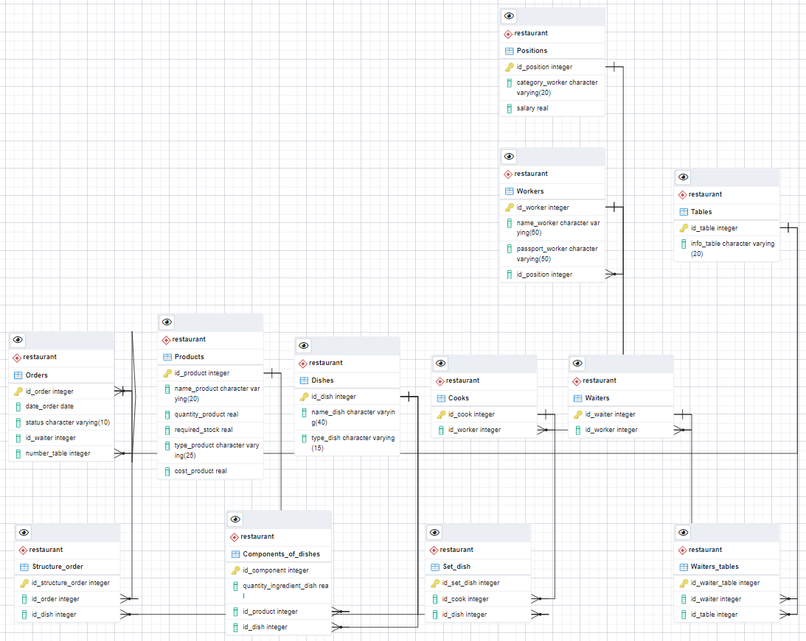

- Скрипты запросов
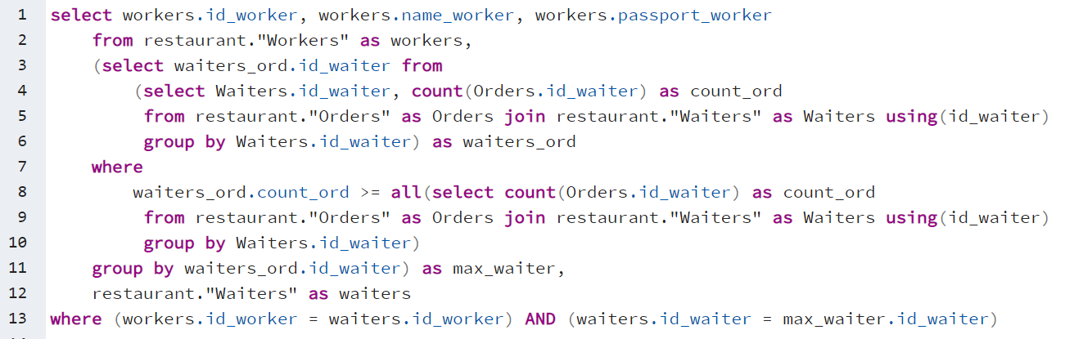
  - Вывести данные официанта, принявшего максимальное число заказов
Результат:


  - Подсчитать, сколько ингредиентов содержит каждое блюдо.
- SELECT d.id_dish, d.name_dish, d.type_dish, count(comp.id_component)
- FROM restaurant."Dishes" AS d,
- restaurant."Components_of_dishes" AS comp
- WHERE (d.id_dish = comp.id_dish)
- GROUP BY d.id_dish
- ORDER BY id_dish;
Результат:
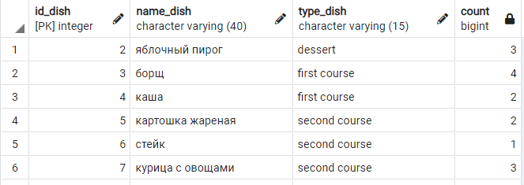

  - Вывести название блюда, содержащее максимальное число ингредиентов.
- SELECT d1.id_dish, d1.name_dish, MAX(d1.num_comp) as num_comp FROM
- (SELECT d.id_dish, d.name_dish, d.type_dish, count(comp.id_component) AS num_comp
- FROM restaurant."Dishes" AS d,
- restaurant."Components_of_dishes" AS comp
- WHERE (d.id_dish = comp.id_dish)
- GROUP BY d.id_dish) AS d1
- WHERE NOT EXISTS
- (SELECT * FROM (
- SELECT d.id_dish, d.name_dish, d.type_dish, count(comp.id_component) AS num_comp
- FROM restaurant."Dishes" AS d,
- restaurant."Components_of_dishes" AS comp
- WHERE (d.id_dish = comp.id_dish)
- GROUP BY d.id_dish) AS d2
- WHERE (d1.num_comp < d2.num_comp ))
- GROUP BY d1.id_dish, d1.name_dish;

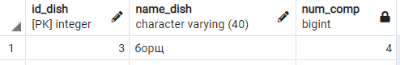
  - Какой повар может приготовить максимальное число видов блюд?
- SELECT cooks.id_cook, cooks.name_worker, cooks.passport_worker, c1.type_count FROM
- (SELECT id_cook, count(distinct type_dish) AS type_count
- FROM restaurant."Set_dish" JOIN restaurant."Dishes" USING (id_dish)
- GROUP BY id_cook) AS c1,
- (SELECT cooks.id_worker, cooks.id_cook, wrk.name_worker, wrk.passport_worker
- FROM restaurant."Cooks" as cooks,
- restaurant."Workers" as wrk
- WHERE (cooks.id_worker = wrk.id_worker)) AS cooks
- WHERE NOT EXISTS
- (SELECT * FROM
- (SELECT id_cook, count(distinct type_dish) AS type_count
- FROM restaurant."Set_dish" JOIN restaurant."Dishes" USING (id_dish)
- GROUP BY id_cook) AS c2
- WHERE c1.type_count < c2.type_count) AND (cooks.id_cook = c1.id_cook);

Результат:

  - Сколько закреплено столов за каждым из официантов?
- SELECT wrk.id_worker, wrk.name_worker, wrk.passport_worker, wtr_cnt.tables_count FROM
- (SELECT wtr.id_waiter, count(distinct wtr_tbl.id_table) AS tables_count
- FROM restaurant."Waiters" AS wtr,
- restaurant."Waiters_tables" AS wtr_tbl
- WHERE (wtr.id_waiter = wtr_tbl.id_waiter)
- GROUP BY wtr.id_waiter) AS wtr_cnt,
- (restaurant."Waiters" JOIN restaurant."Workers" USING (id_worker)) AS wrk
- WHERE wrk.id_waiter = wtr_cnt.id_waiter
- ORDER BY tables_count DESC;

Результат:
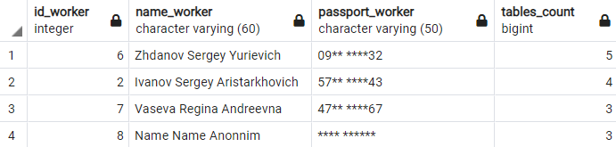

  - Какой из ингредиентов используется в максимальном количестве блюд?
- SELECT cnt1.id_product, cnt1.name_product, cnt1.dishes_cnt
- FROM (SELECT prod.id_product, prod.name_product, count(comp.id_dish) AS dishes_cnt
- FROM restaurant."Components_of_dishes" AS comp,
- restaurant."Products" AS prod
- WHERE (prod.id_product = comp.id_product)
- GROUP BY prod.id_product) AS cnt1
- WHERE NOT EXISTS (SELECT *
- FROM (SELECT prod.id_product, prod.name_product, count(comp.id_dish) AS dishes_cnt
- FROM restaurant."Components_of_dishes" AS comp,
- restaurant."Products" AS prod
- WHERE (prod.id_product = comp.id_product)
- GROUP BY prod.id_product) AS cnt2
- WHERE (cnt1.dishes_cnt < cnt2.dishes_cnt));

Результат:
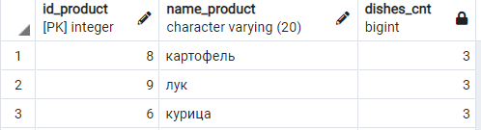
  - Вывести данные официанта, принявшего заказы на максимальную сумму.
- SELECT data1.id_worker, data1.name_worker, data1.passport_worker, data1.worker_sum FROM
- (SELECT workers.id_worker, workers.name_worker, workers.passport_worker, waiters_work.sum AS worker_sum FROM
- (SELECT waiters.id_waiter, SUM(costs_ord.sum_cost_dish) FROM
- (SELECT struct_ord.id_order, SUM(costs.cost_dish) AS sum_cost_dish FROM
- (SELECT comp.id_dish, dishes.name_dish, SUM(comp.quantity_ingredient_dish*prod.cost_product)*1.4 AS cost_dish
- FROM restaurant."Components_of_dishes" AS comp,
- restaurant."Products" AS prod,
- restaurant."Dishes" AS dishes
- WHERE comp.id_dish = dishes.id_dish AND comp.id_product = prod.id_product
- GROUP BY comp.id_dish, dishes.name_dish) AS costs,
- restaurant."Structure_order" AS struct_ord
- WHERE struct_ord.id_dish = costs.id_dish
- GROUP BY struct_ord.id_order) AS costs_ord,
- restaurant."Waiters" AS waiters,
- restaurant."Orders" AS ord
- WHERE (costs_ord.id_order = ord.id_order AND waiters.id_waiter = ord.id_waiter)
- GROUP BY waiters.id_waiter) AS waiters_work,
- (restaurant."Workers" JOIN restaurant."Waiters" USING(id_worker)) AS workers
- WHERE workers.id_waiter = waiters_work.id_waiter) AS data1
- WHERE NOT EXISTS (SELECT * FROM
- (SELECT workers.id_worker, workers.name_worker, workers.passport_worker, waiters_work.sum AS worker_sum FROM
- (SELECT waiters.id_waiter, SUM(costs_ord.sum_cost_dish) FROM
- (SELECT struct_ord.id_order, SUM(costs.cost_dish) AS sum_cost_dish FROM
- (SELECT comp.id_dish, dishes.name_dish, SUM(comp.quantity_ingredient_dish*prod.cost_product)*1.4 AS cost_dish
- FROM restaurant."Components_of_dishes" AS comp,
- restaurant."Products" AS prod,
- restaurant."Dishes" AS dishes
- WHERE comp.id_dish = dishes.id_dish AND comp.id_product = prod.id_product
- GROUP BY comp.id_dish, dishes.name_dish) AS costs,
- restaurant."Structure_order" AS struct_ord
- WHERE struct_ord.id_dish = costs.id_dish
- GROUP BY struct_ord.id_order) AS costs_ord,
- restaurant."Waiters" AS waiters,
- restaurant."Orders" AS ord
- WHERE (costs_ord.id_order = ord.id_order AND waiters.id_waiter = ord.id_waiter)
- GROUP BY waiters.id_waiter) AS waiters_work,
- (restaurant."Workers" JOIN restaurant."Waiters" USING(id_worker)) AS workers
- WHERE workers.id_waiter = waiters_work.id_waiter) AS data2
- WHERE data2.worker_sum > data1.worker_sum)
Результат:
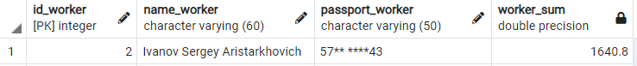

  - Рассчитать премию каждого официанта за последние 10 дней (5% от стоимости каждого заказа).
- SELECT workers.id_worker, workers.name_worker, workers.passport_worker, waiters_work.sum * 0.05 AS prem_sum FROM
- (SELECT waiters.id_waiter, waiters.id_worker, SUM(costs_ord.sum_cost_dish) FROM
- (SELECT struct_ord.id_order, SUM(costs.cost_dish) AS sum_cost_dish FROM
- (SELECT comp.id_dish, dishes.name_dish, SUM(comp.quantity_ingredient_dish*prod.cost_product)*1.4 AS cost_dish
- FROM restaurant."Components_of_dishes" AS comp,
- restaurant."Products" AS prod,
- restaurant."Dishes" AS dishes
- WHERE comp.id_dish = dishes.id_dish AND comp.id_product = prod.id_product
- GROUP BY comp.id_dish, dishes.name_dish) AS costs,
- restaurant."Structure_order" AS struct_ord
- WHERE struct_ord.id_dish = costs.id_dish
- GROUP BY struct_ord.id_order) AS costs_ord,
- restaurant."Waiters" AS waiters,
- restaurant."Orders" AS ord
- WHERE (costs_ord.id_order = ord.id_order AND waiters.id_waiter = ord.id_waiter AND
- (date_order + INTEGER '10' >= CURRENT_DATE))
- GROUP BY waiters.id_waiter) AS waiters_work,
- (restaurant."Workers" JOIN restaurant."Waiters" USING(id_worker)) AS workers
- WHERE workers.id_waiter = waiters_work.id_waiter;
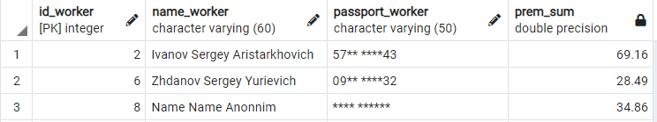
- Запросы на модификацию данных
  - Добавить 3 новых заказа, взяв за основу первые 3 (дату взять сегодняшнюю, а статус задать «принят»)
Содержание таблицы restaurant.”Orders”:
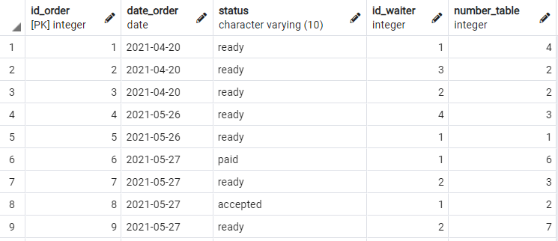
Запрос вставки
- INSERT INTO restaurant."Orders"(
- date_order, STATUS, id_waiter, number_table)
- (SELECT now() AS date_order, 'accepted' AS STATUS, id_waiter, number_table
- FROM restaurant."Orders" WHERE id_order <= 3);

Содержание таблицы restaurant.”Orders” после вставки:
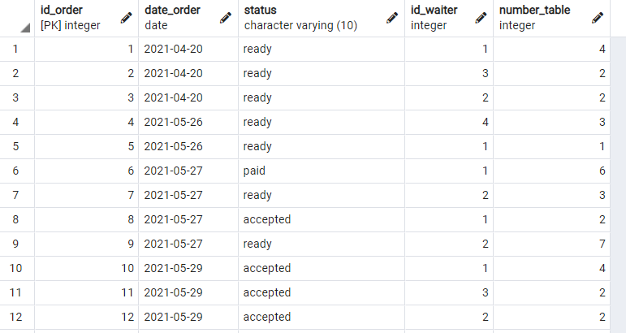

  - Предположим, прошло время, наступил следующий день. Тогда нам нужно изменить статус у всех заказов «accepted» на «canceled» (заказ был принят, но так и не был оплачен).
Содержание таблицы restaurant.”Orders” перед изменением:

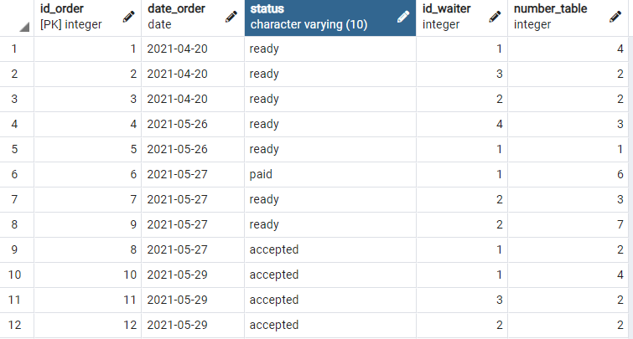
- UPDATE restaurant."Orders"
- SET STATUS = 'canceled'
- WHERE STATUS = 'accepted' AND date_order < CURRENT_DATE;

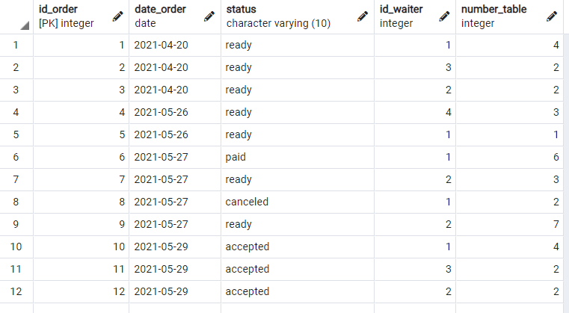
  - Владелец ресторана чрезмерно экономный человек, поэтому требует регулярно избавляться от старых данных в таблице заказов. Нужно удалить всю информацию о заказах, которые были ранее, чем 30 дней назад.
Таблица Orders перед удалением
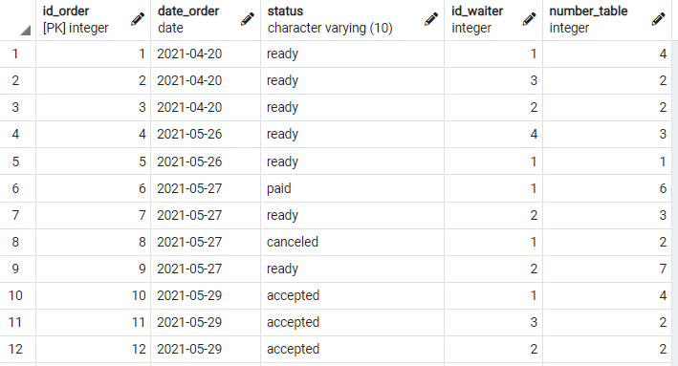

Таблица Structure_order перед удалением
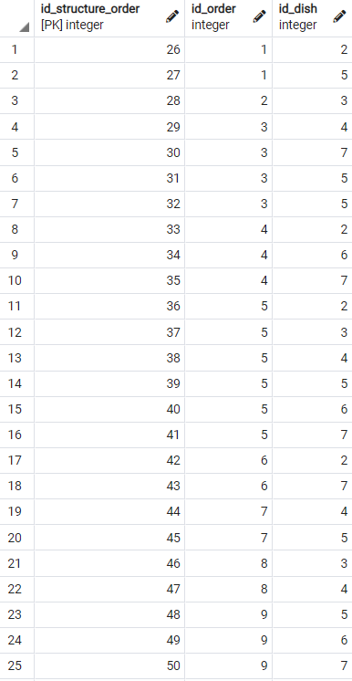
Скрипт удаления данных:
- DELETE FROM restaurant."Structure_order" AS struct
- WHERE struct.id_structure_order IN (SELECT struct.id_structure_order
- FROM restaurant."Orders" AS ord,
- restaurant."Structure_order" AS struct
- WHERE ord.date_order < CURRENT_DATE - INTEGER '30'
- AND struct.id_order = ord.id_order);

- DELETE FROM restaurant."Orders"
- WHERE id_order IN (
- SELECT ord.id_order FROM restaurant."Orders" AS ord
- WHERE ord.date_order < CURRENT_DATE - INTEGER '30');

Таблицы Orders и Structure_order после удаления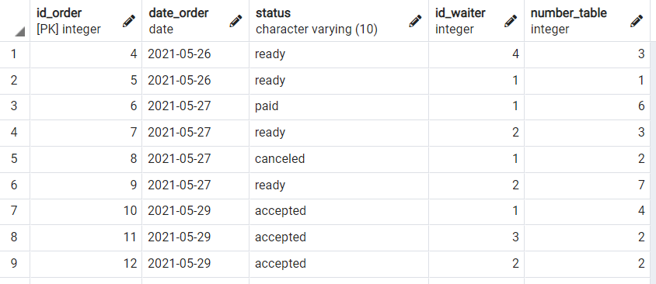 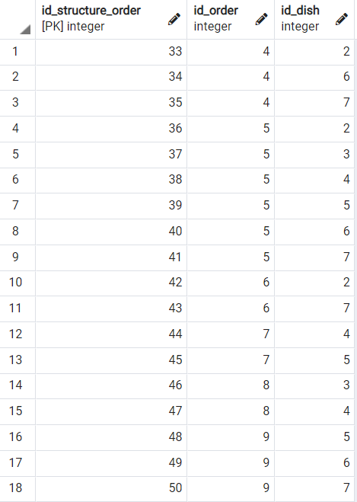

- Создать представления:
  - для расчета стоимости ингредиентов для заданного блюда;
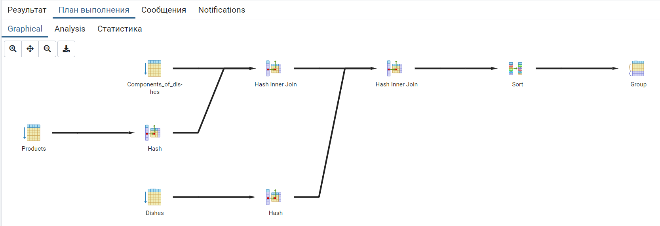
- SELECT dishes.name_dish, prod.name_product,
- comp.quantity_ingredient_dish, prod.cost_product, (comp.quantity_ingredient_dish*prod.cost_product) AS cost_component
- FROM restaurant."Components_of_dishes" AS comp,
- restaurant."Products" AS prod,
- restaurant."Dishes" AS dishes
- WHERE comp.id_dish = dishes.id_dish AND comp.id_product = prod.id_product
- GROUP BY dishes.name_dish, prod.name_product,
- comp.quantity_ingredient_dish, prod.cost_product,(comp.quantity_ingredient_dish*prod.cost_product)
- ORDER BY dishes.name_dish

  - количество приготовленных блюд по каждому блюду за определенную дату.
- SELECT DISTINCT ord.date_order, d.name_dish, COUNT(d.id_dish)
- FROM restaurant."Dishes" AS d,
- (restaurant."Orders" JOIN restaurant."Structure_order" USING(id_order)) AS ord
- WHERE ord.id_dish = d.id_dish
- GROUP BY d.id_dish, ord.date_order
- ORDER BY ord.date_order;

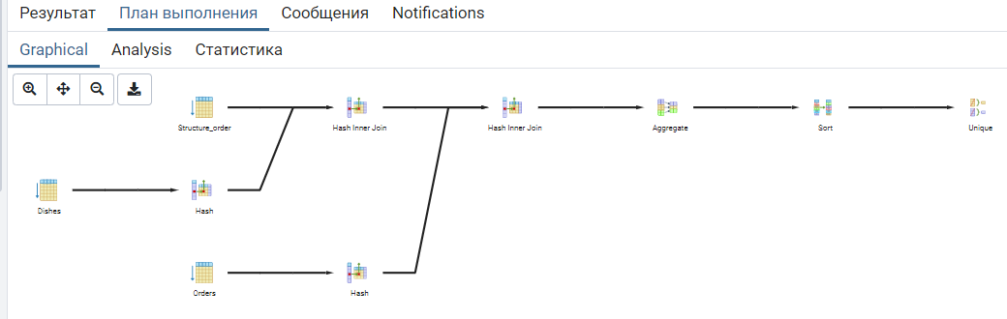
Рисунок 1 – Инфологическая модель данных

